SAT Math Problems

1.  For two acute angles, ∠A and ∠B, $sin(A)=cos(B)$. The measures, in degrees, of ∠A and ∠B are $2x+10$ and $70−x$, respectively. What is the value of $x$?

2.  Circle C has a radius of $5x$ and circle D has a radius of $25x$. The area of circle D is how many times the area of circle C?

A.    10

B.    15

C.    20

D.    25

3.  What is the solution (x, y) to the given system of equations? $2x+3y=12$, $x=2$

A. $(2,\frac{8}{3})$

B.   (2, 3)

C. $(1,\frac{10}{3})$

D.    (0, 4)

4.  In the $xy$-plane, line $m$ has a slope of -2 and a y-intercept of (0, 10). What is the x-coordinate of the x-intercept of line $m$?

A.    -5

B.    0

C.    5

D.    10

5.  The scatterplot shows the relationship between two variables, x and y, for data set C. A line of best fit for the data is also shown in red. If the line of best fit has a slope of approximately 3 and a y-intercept of b, what is the y-coordinate of the y-intercept of the line of best fit for data set C? 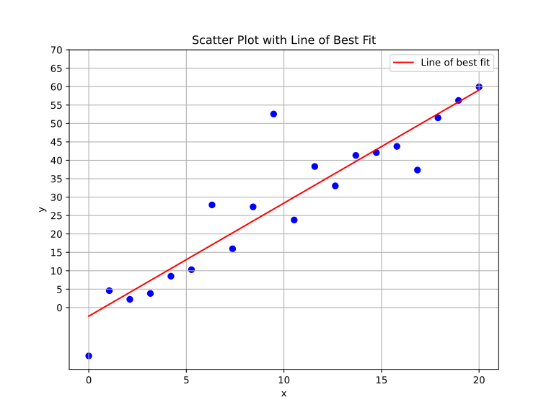

A.    -5

B.    0

C.    5

D.    10

6.  The function N models the number of cyberattacks detected, in thousands, on a Managed Service Provider (MSP) t years after 2020. According to the model, the number of cyberattacks is predicted to increase by $n\%$ every 6 months. What is the value of n? $N(t)=150{\left(1.02\right)}^{2t}$

A. $1\%$

B. $2\%$

C. $3\%$

D. $4\%$

7.  A renewable energy company is analyzing its solar panel installations, which are designed to cover a square area. If the side length of the square area is represented by ’s’ meters and the total energy output is modeled by the function , where E(s) is the energy output in kilowatts, what is the energy output of the solar panels if the side length of the installation area is 4 meters?

A.    88

B.    92

C.    94

D.    98

8.  One solution to the given equation can be written as $x=\frac{−8+\sqrt{m}}{2}$, where m is a constant. What is the value of m? $x^{2}+8x+12=0$

9.  Which expression is equivalent to $(5x^{2}+8x+3)−(2x^{2}+4x)$?

A. $3x^{2}+4x+3$

B. $7x^{2}+12x+3$

C. $3x^{2}+8x+3$

D. $7x^{2}+4x+3$

10.  The table shows the linear relationship between the number of regions, r, and their corresponding influence score on geopolitics, s. Which equation best represents the linear relationship between r and s?

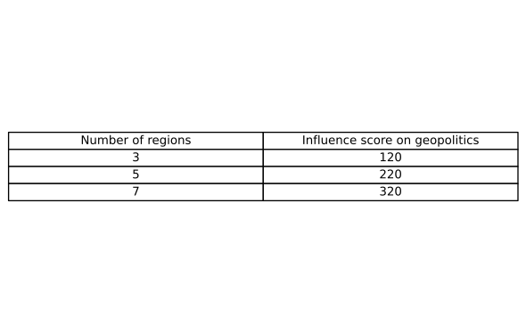

A. $s=45r+20$

B. $s=50r−30$

C. $s=40r+10$

D. $s=55r−25$

SAT Math Solutions

1.  For two acute angles, ∠A and ∠B, $sin(A)=cos(B)$. The measures, in degrees, of ∠A and ∠B are $2x+10$ and $70−x$, respectively. What is the value of $x$?

## Answer

10

## Solution

This problem tests the student’s understanding of the relationship between sine and cosine for complementary angles and their ability to solve equations involving variable expressions for angle measures.  
Recognize that $sin(A)=cos(B)$ implies that angles A and B are complementary, meaning $A+B=90∘$. Use this relationship to set up the equation with the given expressions for angles A and B: $(2x+10)+(70−x)=90$. Solve for x.  
Remember the complementary angle identity: $sin(θ)=cos(90∘−θ)$. Also, ensure that you simplify the equation carefully by combining like terms to make the solving process straightforward.  
Be careful not to confuse the identities or make algebraic errors when solving the equation. Double-check your calculations, especially when simplifying the expressions.  
This problem assesses your knowledge of trigonometric identities and algebraic manipulation. It is a typical SAT question that requires you to connect geometric properties with algebraic equations. Mastery of these foundational concepts is crucial for success in the SAT Math section, particularly under the Geometry and Trigonometry category.  
  
Since $sin(A)=cos(B)$, it follows that $A=90∘−B$.  
Substituting the expressions for ∠A and ∠B: $2x+10=90−(70−x)$ 
  
Simplify the equation: $2x+10=90−70+x$ $2x+10=20+x$ 
  
Subtract x from both sides to get: $x+10=20$  
Subtract 10 from both sides to find $x$: $x=10$

2.  Circle C has a radius of $5x$ and circle D has a radius of $25x$. The area of circle D is how many times the area of circle C?

A.    10

B.    15

C.    20

D.    25

## Answer

D

## Solution

This problem aims to assess the student’s understanding of the relationship between the radius and the area of a circle. Specifically, it examines the ability to apply the formula for the area of a circle and to work with ratios.  
To solve this problem, the student should start by recalling the formula for the area of a circle, which is $A=πr^{2}$. Calculate the area of both circles using their respective radii, then compare the two areas by forming a ratio.  
Remember that the area of a circle increases with the square of its radius. When comparing areas of circles, you can often simplify your work by setting up a ratio instead of calculating exact areas. In this problem, simplify the ratio of the radii first to see the effect on the area.  
Be careful not to confuse the ratio of the radii with the ratio of the areas. The radius is linear, while the area is quadratic. Also, ensure that you square the radii correctly and apply the π factor consistently.  
This type of problem is common in SAT geometry questions and tests the ability to understand and manipulate geometric formulas, specifically circles. It also assesses the student’s skill in working with proportions and recognizing how changes in one dimension (radius) affect another dimension (area). Mastery of these concepts is crucial not only for geometry but also for more advanced topics in mathematics.  
  
Calculate the area of circle C: $A_{C}=π{\left(5x\right)}^{2}=25πx^{2}$  
Calculate the area of circle D: $A_{D}=π{\left(25x\right)}^{2}=625πx^{2}$  
The ratio of the area of circle D to circle C is: $\frac{A_{D}}{A_{C}}=\frac{625πx^{2}}{25πx^{2}}=25$.  
Thus, the area of circle D is 25 times the area of circle C.

3.  What is the solution (x, y) to the given system of equations? $2x+3y=12$, $x=2$

A. $(2,\frac{8}{3})$

B.   (2, 3)

C. $(1,\frac{10}{3})$

D.    (0, 4)

## Answer

A

## Solution

This problem is designed to assess the student’s ability to solve a system of linear equations, specifically to find the point of intersection of two lines, which represents the solution of the system when there is one unique solution.  
Start by substituting the given value of x from the second equation into the first equation. This substitution simplifies the system to a single equation in one variable (y), which can then be solved easily. Once y is found, the solution (x, y) can be stated.  
Since one of the equations directly provides the value of x, make sure to use this to simplify the process. Substitute $x=2$ into the first equation immediately to find y without additional steps.  
Be careful with the arithmetic when solving for y after substitution. Double-check the calculations to ensure accuracy, especially when involving basic operations like addition, subtraction, and division.  
This type of problem is straightforward and tests basic algebraic manipulation skills. The key is recognizing the direct substitution opportunity that simplifies the problem significantly. By practicing more problems of this type, students can improve their speed and accuracy in solving systems of equations. This problem showcases the SAT’s focus on assessing problem-solving skills and understanding of algebraic concepts.  
  
Given the system of equations:  
1.   
2. , Substitute $x=2$ into the first equation: $2(2)+3y=12$, $4+3y=12$  
Subtract 4 from both sides: $3y=8$, Divide both sides by 3: $y=\frac{8}{3}$  
Thus, the solution to the system is $(x,y)=(2,\frac{8}{3})$.

4.  In the $xy$-plane, line $m$ has a slope of -2 and a y-intercept of (0, 10). What is the x-coordinate of the x-intercept of line $m$?

A.    -5

B.    0

C.    5

D.    10

## Answer

C

## Solution

This problem tests the student’s understanding of the equation of a line in slope-intercept form, specifically their ability to use the given slope and y-intercept to find the x-intercept.  
To solve this problem, use the slope-intercept form of a line, $y=mx+b$, where m is the slope and b is the y-intercept. Substitute the given slope (-2) and y-intercept (10) into the equation to get $y=−2x+10$. To find the x-intercept, set y to 0 and solve for x.  
Remember that the x-intercept occurs where the graph of the line crosses the x-axis, which means $y=0$ at that point. Use this information to simplify the equation and solve for x. Be careful with the signs while solving the equation. A common mistake is to misinterpret the slope or miscalculate when isolating x.  
This type of problem is fundamental in understanding linear equations and their graphs. It assesses your ability to manipulate and solve linear equations using given parameters. Mastery of these concepts is crucial as they form the basis for more advanced algebraic topics.  
  
The general equation of a line in slope-intercept form is $y=mx+b$.  
Here, $m=−2$ and $b=10$, so the equation of the line is $y=−2x+10$.  
To find the x-intercept, set $y=0$ and solve for x:, $0=−2x+10$, $2x=10$, $x=5$  
Therefore, the x-coordinate of the x-intercept is 5.

5.  The scatterplot shows the relationship between two variables, x and y, for data set C. A line of best fit for the data is also shown in red. If the line of best fit has a slope of approximately 3 and a y-intercept of b, what is the y-coordinate of the y-intercept of the line of best fit for data set C? 

A.    -5

B.    0

C.    5

D.    10

## Answer

A

## Solution

This problem assesses the student’s ability to understand the concept of a line of best fit in a scatter plot, particularly focusing on identifying the y-intercept from the line’s equation.  
To solve this problem, you need to recognize that the line of best fit is represented by the equation $y=mx+b$, where m is the slope and b is the y-intercept. The problem provides the slope ($m=3$) and asks for the y-intercept (b). If the scatter plot or additional information like a specific point on the line is given, use it to solve for b.  
If there is a point on the line of best fit provided in the scatter plot, substitute the x and y values of this point into the equation $y=3x+b$ to solve for b. Alternatively, if the plot shows where the line crosses the y-axis, that coordinate is directly the y-intercept.  
Be careful not to confuse the slope with the y-intercept. Remember that the y-intercept is where the line crosses the y-axis, which corresponds to the x-value of 0. Ensure you correctly interpret the graph to identify this point.  
This type of problem is standard in the SAT to test students’ ability to interpret scatter plots and understand linear relationships. It evaluates how well students can apply the equation of a line to real-world data. Mastery of this concept is essential, as it forms the basis for more complex data analysis questions. In the SAT context, being able to quickly and accurately identify components of a linear equation from a graph is a valuable skill.  
  
The equation for the line of best fit is generally given by $y=mx+b$, where m is the slope, and b is the y-intercept.  
Given $m=3$, we substitute this into the line equation: $y=3x+b$.  
We can interpret the graph ; y-intercept is a negative value.  
So, A) -5 is reasonable answer.

6.  The function N models the number of cyberattacks detected, in thousands, on a Managed Service Provider (MSP) t years after 2020. According to the model, the number of cyberattacks is predicted to increase by $n\%$ every 6 months. What is the value of n? $N(t)=150{\left(1.02\right)}^{2t}$

A. $1\%$

B. $2\%$

C. $3\%$

D. $4\%$

## Answer

B

## Solution

This problem is designed to test the student’s understanding of exponential growth, specifically how to interpret and manipulate exponential functions to find the rate of increase, given a specific time frame (in this case, every 6 months).  
To solve this problem, recognize that the function provided, $N(t)=150{\left(1.02\right)}^{2t}$, is an exponential function where the base, 1.02, represents the growth factor for each 6-month period. The task is to find the percentage increase, $n\%$, which corresponds to this growth factor.  
Remember that the base of the exponential function, 1.02 in this case, is equal to 1 plus the rate of increase expressed as a decimal. So, to find $n\%$, you need to subtract 1 from the base and then multiply by 100 to convert it to a percentage. Therefore, $n\%=(1.02−1)×100\%$.  
Be careful not to confuse the growth factor with the percentage increase. The growth factor is 1.02, which means the actual percentage increase is slightly more than $2\%$ per 6 months, not $2\%$ itself. Also, ensure you understand that the exponent 2t indicates doubling the growth period to account for annual growth.  
This type of problem is fundamental in the SAT as it assesses the student’s ability to interpret exponential models and understand the concept of compounding growth over different time frames. Mastery of these concepts is crucial for handling more complex real-world problems involving exponential growth or decay. Practice converting between growth factors and percentage increases to become more comfortable with these calculations.  
  
Given the formula for exponential growth, the growth factor is 1 plus the rate of growth expressed as a decimal.  
If the growth factor is 1.02, then this implies a growth rate of 0.02.  
To convert the growth rate into a percentage, multiply by 100.  
So, $0.02×100=2$, which means the growth rate is $2\%$ every 6 months.

7.  A renewable energy company is analyzing its solar panel installations, which are designed to cover a square area. If the side length of the square area is represented by ’s’ meters and the total energy output is modeled by the function , where E(s) is the energy output in kilowatts, what is the energy output of the solar panels if the side length of the installation area is 4 meters?

A.    88

B.    92

C.    94

D.    98

## Answer

C

## Solution

This problem tests the student’s understanding of polynomial functions, specifically higher-degree polynomials, and their ability to evaluate these functions given a specific value for the variable.  
To solve this problem, the student needs to substitute the given side length ’s’ into the polynomial function $E(s)$ and perform the arithmetic operations to find the energy output.  
Firstly, plug the given side length ($s=4$) into the function $E(s)$. Make sure to follow the order of operations ($\frac{PEMDAS}{BODMAS}$) carefully: calculate the square term first, then the linear term, and finally add the constant term. Simplify step by step to avoid mistakes.  
Be careful with the operations, especially squaring the side length and adding the terms in the correct order. Common mistakes include forgetting to square the side length or misplacing the decimal points. Double-check your calculations to ensure accuracy.  
This type of problem is common in the SAT Advanced Math section and aims to evaluate the student’s ability to work with polynomial functions and apply them to real-world contexts. Developing proficiency in these types of problems requires practice in substituting values into polynomial expressions and performing arithmetic operations accurately. Being meticulous and systematic in your approach will help minimize errors and improve efficiency.  
  
Substitute $s=4$ into the function $E(s)$.  
Calculate $E(4)=5{\left(4\right)}^{2}+3(4)+2$.  
First, calculate $4^{2}=16$.  
Next, calculate $5×16=80$.  
Then, calculate $3×4=12$.  
Now, sum these results: $80+12+2=94$.  
So, the energy output when the side length is 4 meters is 94 kilowatts.

8.  One solution to the given equation can be written as $x=\frac{−8+\sqrt{m}}{2}$, where m is a constant. What is the value of m? $x^{2}+8x+12=0$

## Answer

16

## Solution

The problem tests the student’s ability to use the quadratic formula to find the roots of a quadratic equation. It assesses understanding of the formula’s components and how they relate to the coefficients of the quadratic equation.  
To solve this problem, the student should identify the coefficients a, b, and c from the quadratic equation $x^{2}+8x+12=0$, where $a=1,b=8, and c=12$. Then, they should apply the quadratic formula $x=\frac{−b±\sqrt{b^{2}−4ac}}{2a}$ to determine the expression under the square root, which is the discriminant $(b^{2}−4ac)$.  
Remember, the discriminant $(b^{2}−4ac)$ determines the nature of the roots of a quadratic equation. For this problem, since the solution is given in the form $x=\frac{−b+\sqrt{m}}{2}$, calculate $(b^{2}−4ac)$ to find the value of m directly.  
Be careful with calculations involving the square root and ensure you use the correct values for a, b, and c in the quadratic formula. Double-check your arithmetic to avoid errors, particularly when calculating $(b^{2}−4ac)$.  
This problem is a classic example of using the quadratic formula, a fundamental skill in algebra. Understanding how to manipulate and solve quadratic equations using this formula is crucial for success in more advanced mathematics. The SAT often includes questions that require detailed understanding and application of quadratic equations, so mastering this technique can significantly benefit students.  
  
Apply the quadratic formula to the equation $x^{2}+8x+12=0$.  
Identify $a=1,b=8,c=12$.  
Compute the discriminant: $b^{2}−4ac=8^{2}−4(1)(12)=64−48=16$.  
Substitute into the quadratic formula: $x=\frac{−8±\sqrt{16}}{2}$.  
Hence, $m=16$.

9.  Which expression is equivalent to $(5x^{2}+8x+3)−(2x^{2}+4x)$?

A. $3x^{2}+4x+3$

B. $7x^{2}+12x+3$

C. $3x^{2}+8x+3$

D. $7x^{2}+4x+3$

## Answer

A

## Solution

The problem aims to test the student’s understanding of polynomial operations, specifically subtraction of quadratic polynomials. It assesses the student’s ability to correctly apply the distributive property and combine like terms.  
To solve this problem, students should first distribute the negative sign through the second polynomial, then combine like terms to simplify the expression.  
Here are the steps:  
1. Distribute the negative sign: .  
2. Combine like terms: $5x^{2}−2x^{2}+8x−4x+3=3x^{2}+4x+3$  
Make sure to carefully distribute the negative sign to both terms in the second polynomial. It’s often helpful to write out each step clearly to avoid mistakes. Always double-check that you have combined all like terms correctly.  
One common mistake is forgetting to distribute the negative sign to the second polynomial, which can lead to incorrect terms. Another potential error is incorrectly combining the like terms, especially with the coefficients. Pay close attention to the signs and coefficients of each term. This problem is a fundamental exercise in polynomial operations, specifically subtraction. It evaluates a student’s ability to manage algebraic expressions accurately by distributing signs and combining like terms. Mastery of these skills is crucial for more advanced algebraic manipulations and is frequently tested in the SAT. Taking systematic steps and being cautious of sign changes are key strategies to avoid errors.  
  
Start with the given expression: $(5x^{2}+8x+3)−(2x^{2}+4x)$.  
Distribute the negative sign across the second polynomial: $5x^{2}+8x+3−2x^{2}−4x$.  
Combine like terms: $5x^{2}−2x^{2}=3x^{2}$, $8x−4x=4x$, 3 remains as a constant term.  
The simplified expression is $3x^{2}+4x+3$.

10.  The table shows the linear relationship between the number of regions, r, and their corresponding influence score on geopolitics, s. Which equation best represents the linear relationship between r and s?



A. $s=45r+20$

B. $s=50r−30$

C. $s=40r+10$

D. $s=55r−25$

## Answer

B

## Solution

This problem assesses the student’s ability to interpret data from a table and derive a linear equation that represents the relationship between two variables. It tests understanding of linear functions, slope, and y-intercept.  
To approach this problem, examine the table to identify the change in the influence score, s, as the number of regions, r, changes. Calculate the slope (rate of change) by finding the difference in the scores divided by the difference in the corresponding regions. Use one of the data points to solve for the y-intercept by substituting known values into the linear equation format, $y=mx+b$, where m is the slope and b is the y-intercept.  
Start by carefully examining the table to determine the pattern or consistent change between the variables. The slope is consistent in a linear relationship, so look for this regular increase or decrease. After finding the slope, don’t forget to use a point to find the y-intercept to complete the equation. This ensures the equation is accurate for all points in the table.  
Double-check your calculations for the slope and y-intercept. Ensure you are consistent with the units and that you have accurately interpreted the table. Common mistakes include using incorrect data points or miscalculating the slope by confusing the change in regions with the change in scores.  
This type of problem is common in the SAT Algebra section, where understanding linear relationships is crucial. It combines data interpretation and algebraic skills, requiring students to transition from tabular data to a mathematical equation. Mastery of these problems involves recognizing patterns and accurately applying the slope-intercept form of a line. Practice with various datasets will improve speed and accuracy.  
  
Using the points (3, 120) and (5, 220) to calculate the slope (m): $m=\frac{220−120}{5−3}=\frac{100}{2}=50$  
Using the slope and one of the points to find the y-intercept (b). $s=mr+b$ 
, $120=50×3+b$, $120=150+b$, $b=120−150$, $b=−30$  
Therefore, the equation of the line is $s=50r−30$.